

Water Orders through DitchManangement.com

# Introduction

The purpose of this document is to step a User through submitting and tracking water requests via the DitchManagement.com web application. A User is an individual who has an account on the system and is able to perform any of the steps below. If someone would like to use the system but does not have a User account, one can be created by contacting [Angie@DanGrantBookkeeping.com](mailto:Angie@DanGrantBookkeeping.com). Please provide: Full Name, the shareholder(s) name you are associated with, phone number and valid email address. Once the User account is created, you will be sent an email to log in to the system and setup a password and security question.

# Log In to the Water Management System

Logging into the system can be done from [BoulderWhiteRock.com](http://www.boulderwhiterock.com/boulderwhiterock/Account/Login.aspx). On BoulderWhiteRock.com, there is a “Log In" link in the upper right hand corner.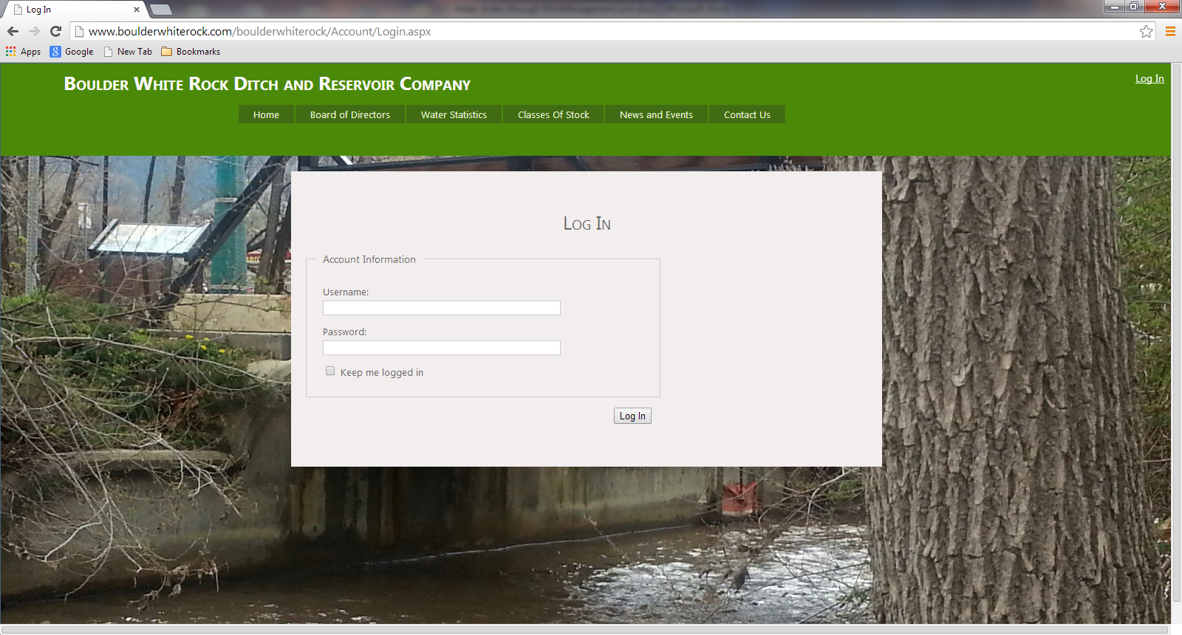

# Manage Page

Once you successfully log in, you will be on the user Manage page:

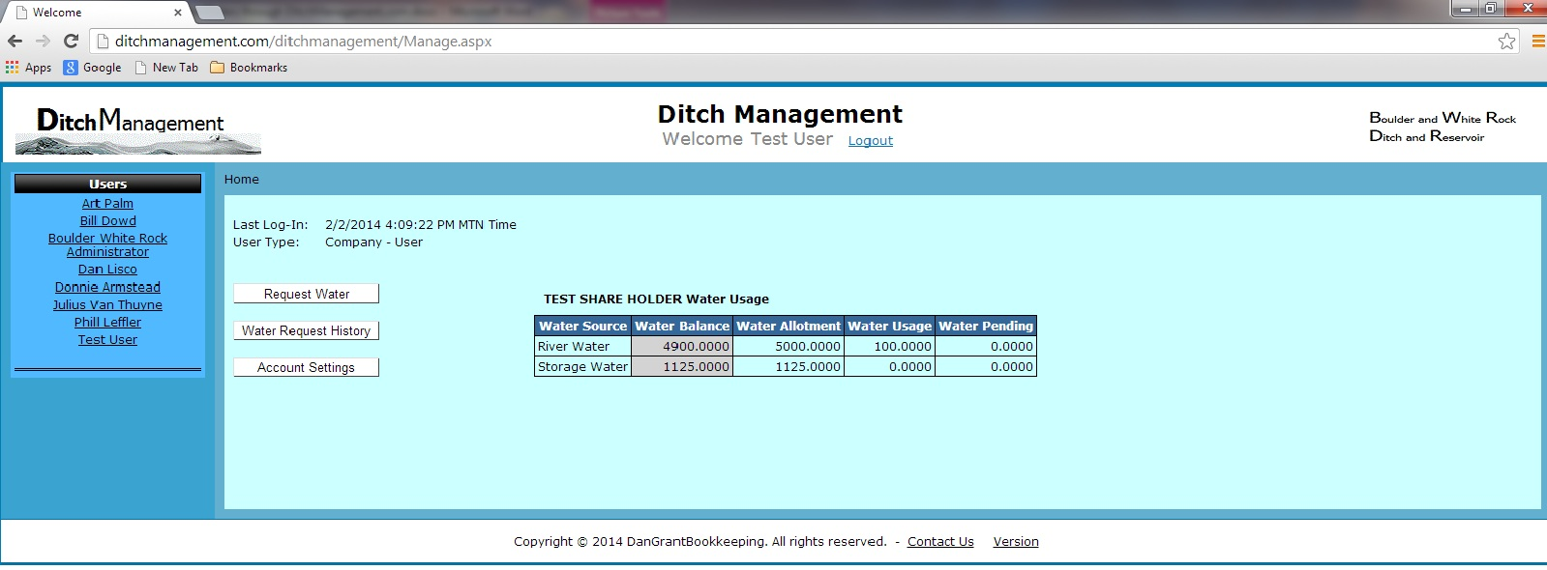

On this page you will have a “Water Usage” summary in the center of the page. The grid displays share holder information as:

* Water Source – distribution source of the water.
* Water Balance – current balance for the water source (Water Allotment – Water Usage – Water Pending.)
* Water Allotment – current season’s full allotment of water available based upon share amount.
* Water Usage - water that has been requested and approved also includes water already distributed.
* Water Pending – amount of water that has been submitted for delivery but has not been reviewed and approved.

On the Manage page the first button is “Request Water.” When clicking the button, the user is redirected to the Request Water page.

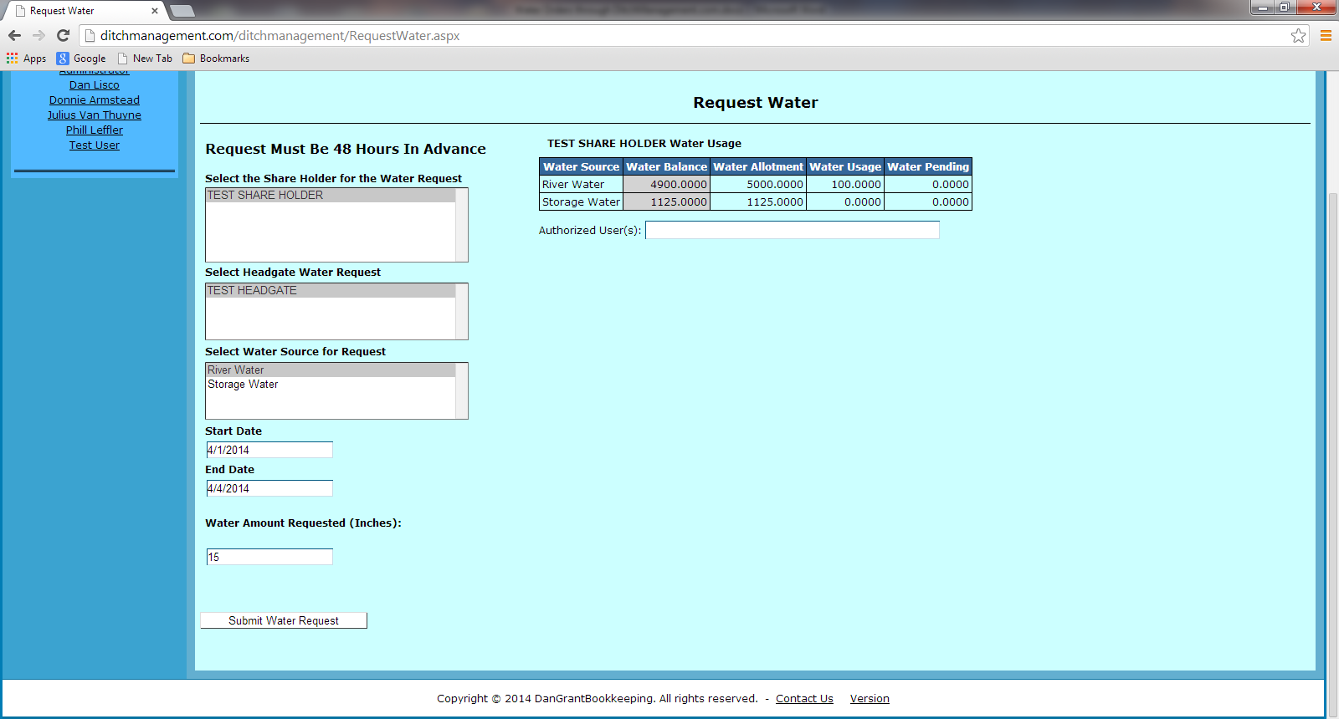

On the “Request Water” page, a user will be able to submit a water request for dates that are 48 hours out. To complete the request select a Share Holder, Head gate, Start Date, End Date and Amount of water (in inches) to be distributed. Once the required information is completed, the user will click on “Submit Water Request.” In doing so, they will receive a message that states **Water Request has been submitted and notifications sent.** This will send an email to the Ditch Rider and user, confirming the request was logged. The Ditch Rider will then review, possibly edit, and approve the request. Once this process is complete, the user will receive an email notification of the approval with any comments that are applicable.

# Water Request

From the Manage page, the second button option is “Water Request History.” When the user clicks the button, they will be redirected to the Water Request History page. On this page a user will be able to view all water activity that has occurred. Search options are:

* Begin Search Date –beginning date for search criteria.
* End Search Date – ending date for search criteria.
* Search On – allows a user to search by Request Date or Start date of the water requests.
* Completed Status – allows a user to filter by Completed, Not Completed or Both water request statuses.

When the above information is filled in, the user can click on “Search” and a grid of activity is returned. If the Date parameters are left blank and “Search” is clicked, all activity is returned with no Date filter applied.

